1.Compile and Execute the C program to calculate Arithmetic Operators Functions such as Pow(x,n), Add(x,n), Sub(x,n), Mul(x,n), Div(x,n), where x and n are the two
operands. Get the input and choice from the user.

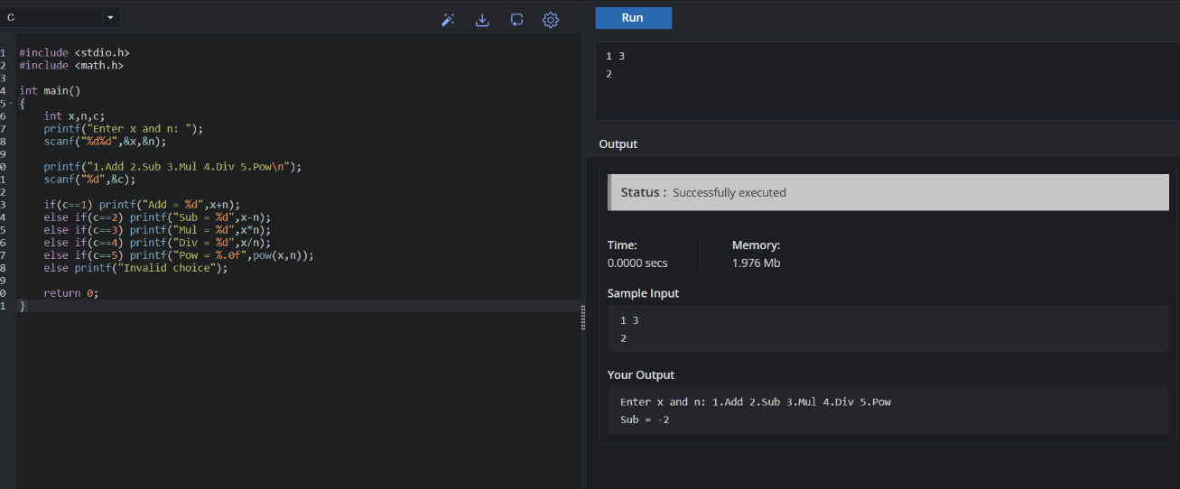

2.Compile and Execute the C program to change all the digits of a number to bring the
digit at the last position to the first position and vice-versa using loop. Get the input
from user.
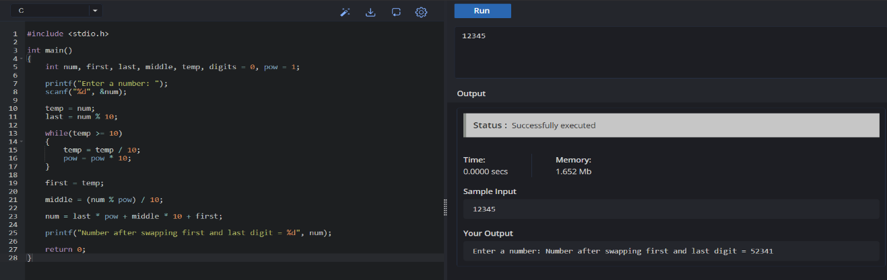

3.Compile and Execute the C program to find the Factorial of a positive integer
(number) is the sum of multiplication of all the integers smaller than that positive
integer. N! is denoted as factorial of N. For example, factorial of 5 is 5 * 4 * 3 * 2 * 1
which equals to 120.
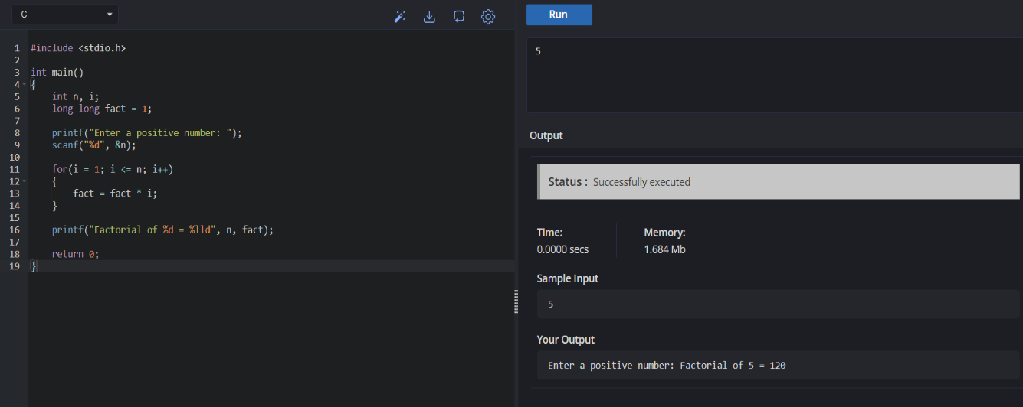

4.Suppose the number to be check is 6: The user has provided one number that is ‘6’,
now we have to think and calculate by which other numbers we can divide ‘6’ and get
the remainder as ‘0’. If the remainder is zero, then we can say that ‘6’ is divisible by
that number and we can take this number into consideration to get the sum by using
some more other numbers. Compile and execute the above C program.
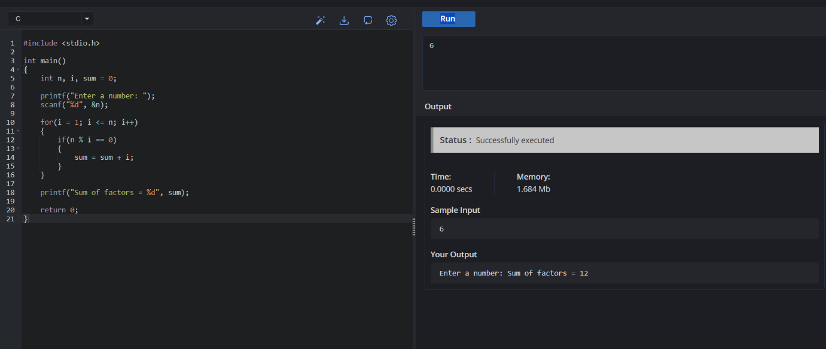

5.Compile and Execute the C program were the user to enter an integer to compute the
square, cube of the given decimal number using standard method.

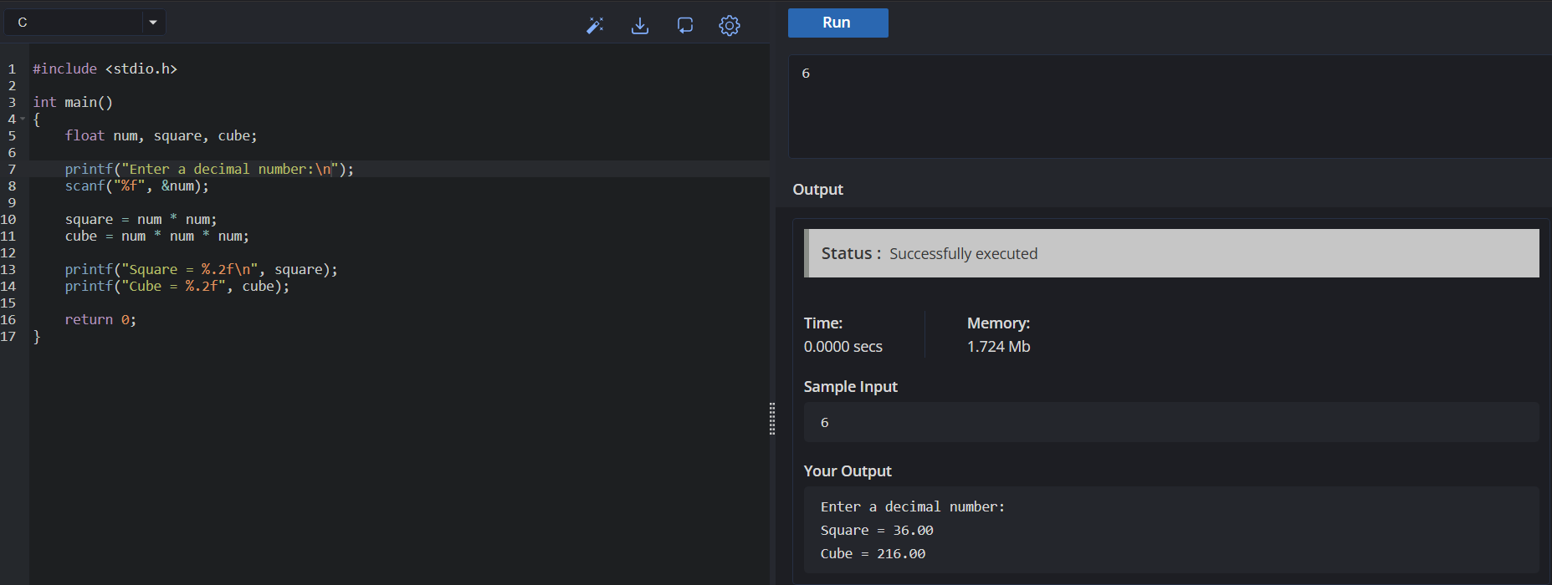

6.Compile and Execute the C program to find whether the person is eligible for vote or
not. And if that particular person is not eligible, then print how many years are left to
be eligible.

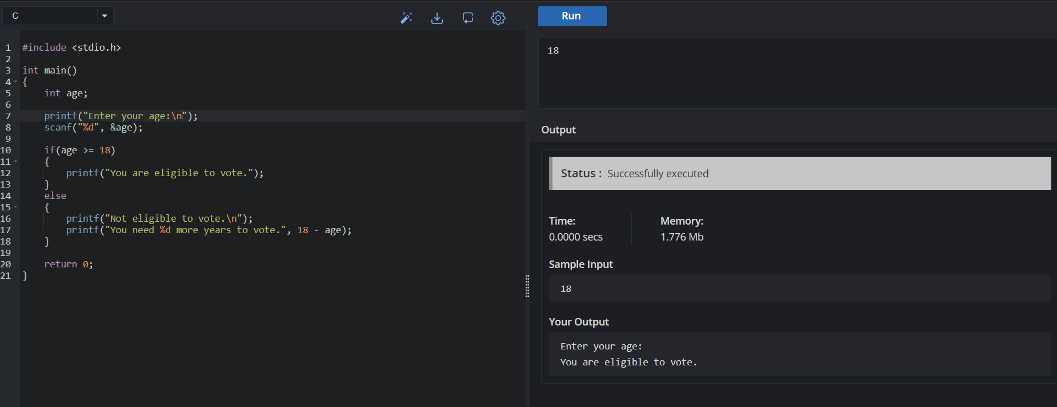

7.Compile and Execute the C program to check whether the number divisible by 2, then
print the given number even otherwise odd. Check and display the output on the
screen.

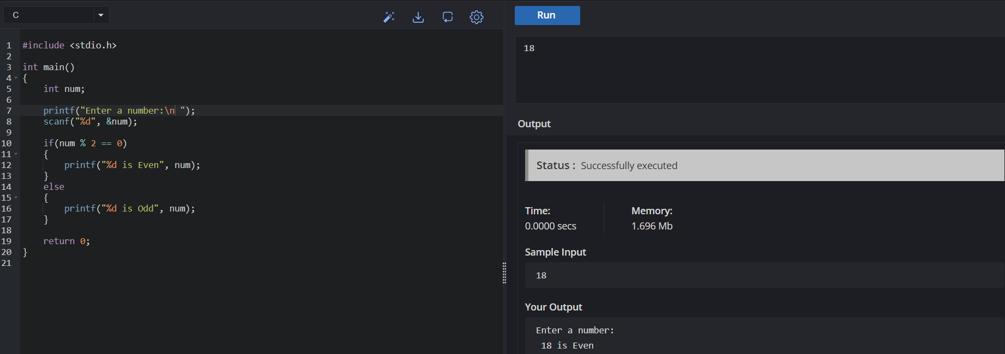

8.Compile and Execute the C program to print numbers from P to Q but except
the digit R using continue statement. Check and display the output on the screen
Sample Output:
Numbers are = 60, 61, 62, 64, 65, 66, 67, 68, 69, 70

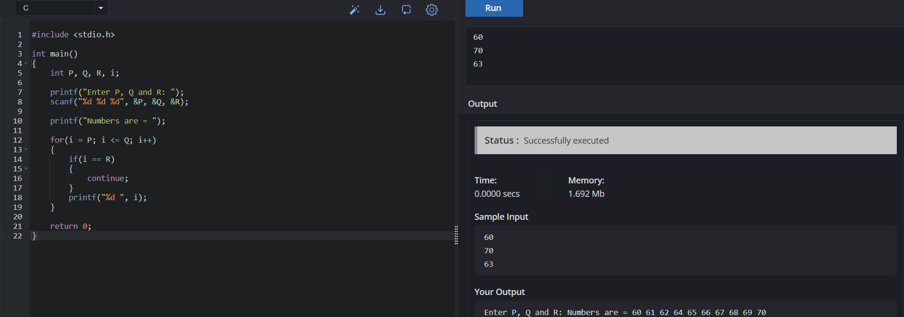

9.Write a program to print the following pattern. Get the number of rows from the user.
Sample input:
Number of Rows: 5
Sample output:
1
2 1
3 2 1
4 3 2 1
5 4 3 2 1
Test case:
Number of Rows: 0.5
Test Condition:
Number of Rows: 5
Sample Output:
1
4 1
9 4 1
16 9 4 1
25 16 9 4 1
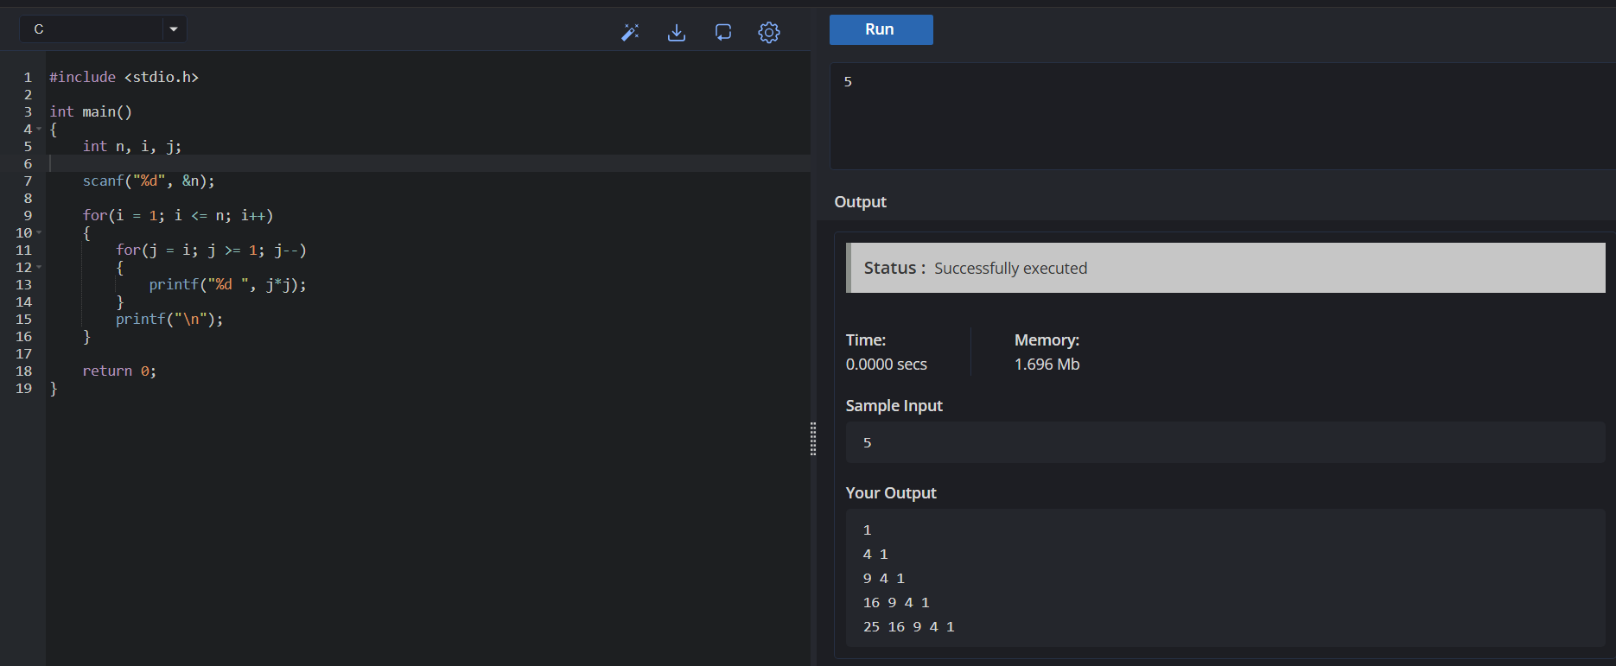
10.Write a program to print the below pattern.
Sample Input:
Number of line: 4
Sample output:
1
2 2
3 3 3
4 4 4 4
Test case:
Number of line:0.4
Test condition:
Number of line:4
0.1
0.2 0.2
0.3 0.3 0.3
0.4 0.4 0.4 0.4
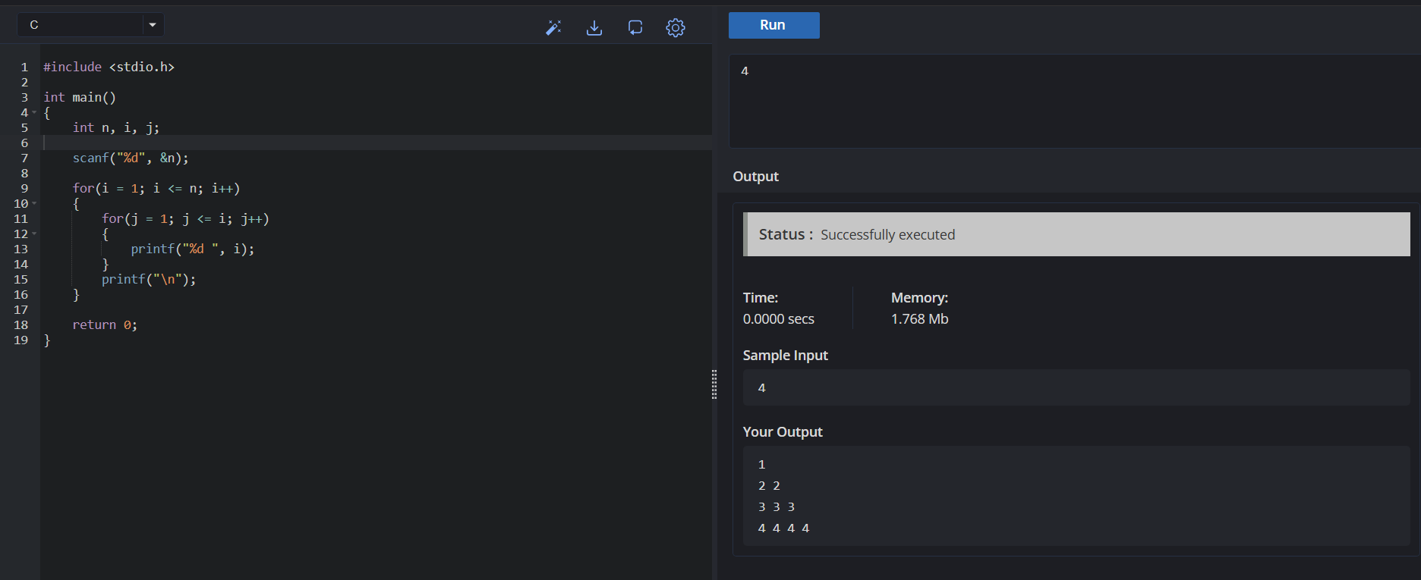

11.Compile and Execute the C program to print the multiplication table of number m up to n.
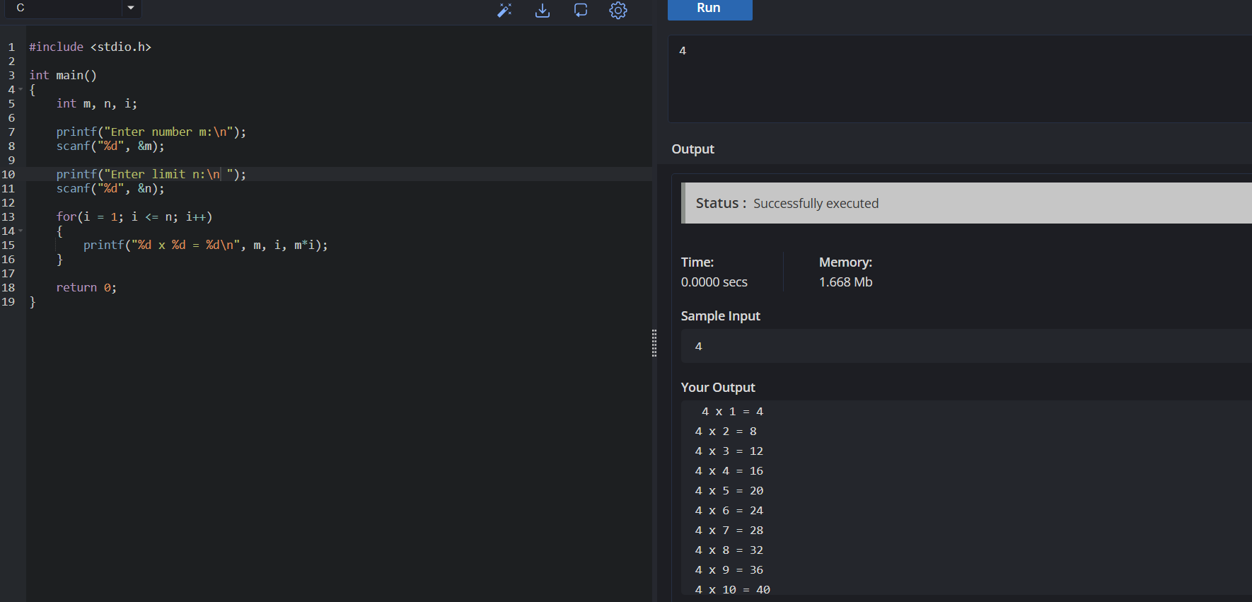

12.Permutation refers number of ways in which set members can be arranged or ordered in some fashion. Compile and execute the C program to print unique permutations of a given number.
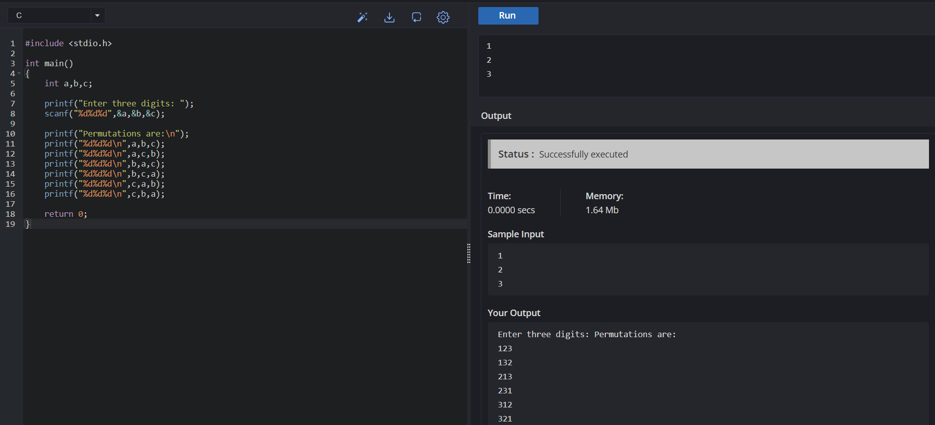

13.Write a program to print the all Odd numbers and number of even numbers in
between M and N?
Sample Input:
M = 6
N = 15
Sample Output:
All Odd Numbers = 7,9,11,13
All Even Numbers = 8,10,12,14
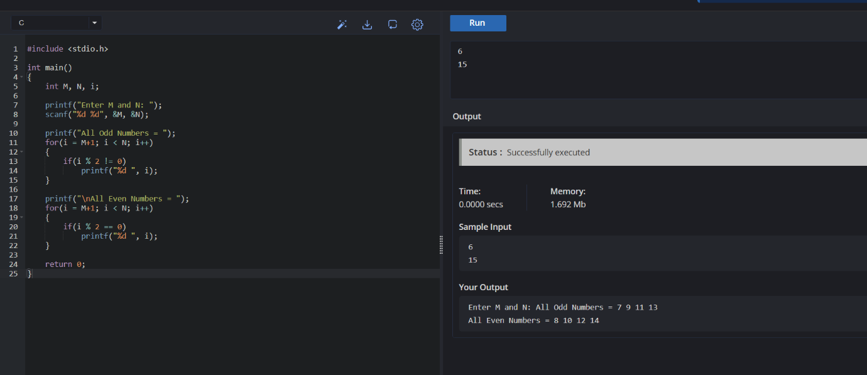

14.Write a program to find the number of student users in the college, get the total users,
staff users details from the client. Note for every 3 staff user there is one Non teaching
staff user assigned by default.
Sample Input:
Total Users: 856
Staff Users: 126
Sample Output:
Student Users: 688

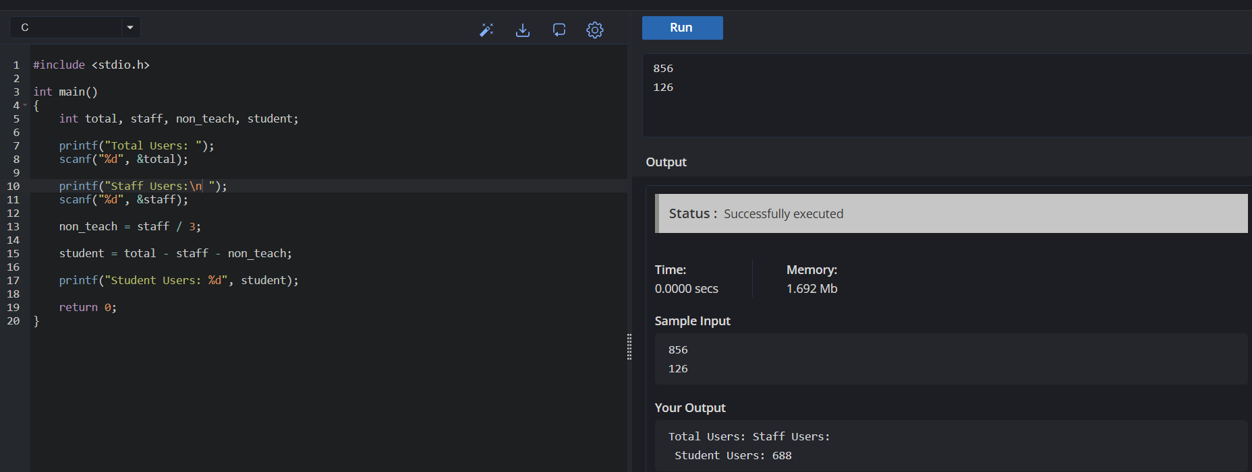
15.Write a program to calculate the simple interest. Suppose the customer is a senior
citizen. He is being offered 12 percent rate of interest; for all other customers, the ROI
is 10 percent.
Sample Input:
Enter the principal amount: 200000
Enter the no of years: 3
Is customer senior citizen (y/n): n
Sample Output:
Interest: 60000
